The Little Mermaid

Date:

Writer:

Genre: Fairy tale

Reading time:

Reading tasks:

**Task1.** Read the story and finish the plot line, story map or the mini story picture book.(Choose a way you like.)(读故事，完成故事情节线，故事地图或者故事连环画, 任选一种方式。）

**Task2.** Choose one of the characters from the Little Mermaid, the grandmother,and the prince, then finish the character traits.（从3个角色中任选一个完成角色分析：小美人鱼，奶奶，王子）

**Task3.** Open questions. (Choose one of the topic to write about.)开放问题（任选其一完成）

1. If you were the Little Mermaid, would you choose to trade your voice for the potion from the sea witch? Why or why not?
2. Please write a different ending for the story.

**Task4**. In the story, a lot of similes(比喻）（usually as or like are used in the sentence） are used, write down 5 sentence with simile you like best, and put them into Chinese.（故事中运用了大量的比喻（在句子中运用“as”或“like”），在文中找出你最喜欢的5句，摘抄下来，并译成中文。）

Eg. Outside the castle was a large garden with trees as red as fire and as blue as night sky.

在城堡外面是一个巨大的花园，里面长着树木，有的像火焰一样通红，有的像夜空一样湛蓝。

**Task4.** When the sisters came up to the surface of the sea, they saw different things. Read those parts again and find the sentences that can be used to describe the following pictures. （当小美人鱼的姐姐们第一次浮出水面看人间世界时，她们看到了不同的景象，从文中的那些段落中找出最好地描述以下画面的句子，并抄写下来。）

The first sister:

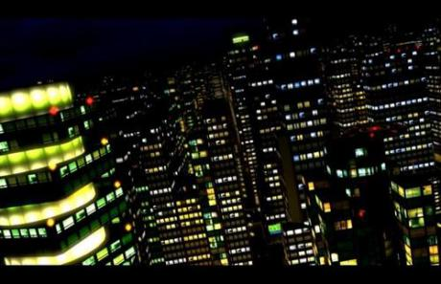

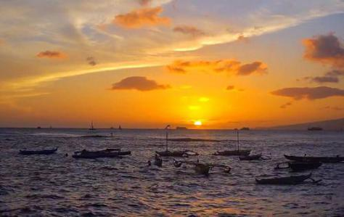

The second sister:

The fourth sister:

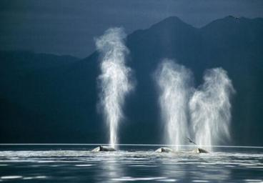

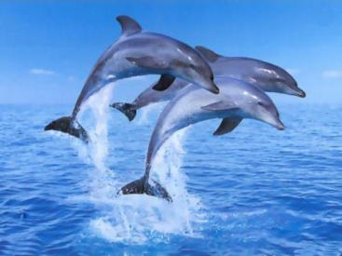

The fifth sister:

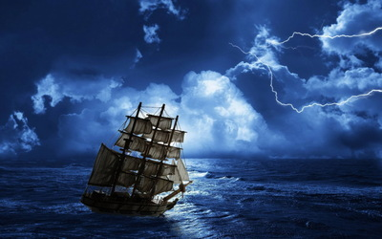

**Task5**. Read and draw. Read paragraph2 on page 39, or paragraph 3 on page 4o, draw a picture according to what you’ve read, and write down the names of the things in the picture.（读后绘画。读文中的这两个段落，并把其中的一个情景画下来，并把图中的东西标上名称。）

39页第2段：Now, it certainly shouldn’t be thought that the bottom is only bare and sandy. ...any of which will be highly prized in a queen’s crown.

40页第3段：Outside the castle was a large garden, ...It looked like a purple flower from whose chalice the light streamed out.

**Task6**. In the story, the writer used similes to describe a lot of scenes vividly. Find a picture on the internet, and write a paragraph to describe the picture, using similes to make your description vivid. （文中作者运用了大量的比喻句，是描述非常的生动。请在网上找一张图片，写一段话来描述你选择的图片，在描述中运用比喻句。）

Task1 可选用的呈现方式，按自己的喜好，任选一种方式。

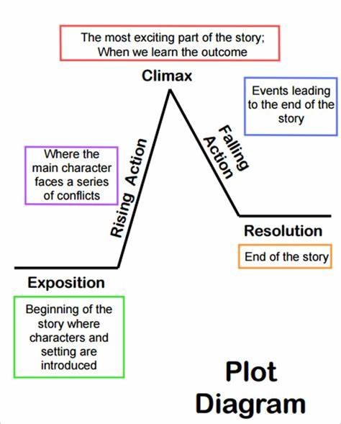

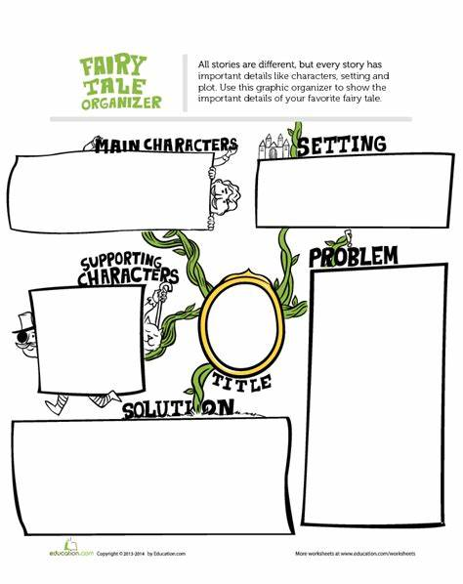

故事背景

主角

问题

配角

结局

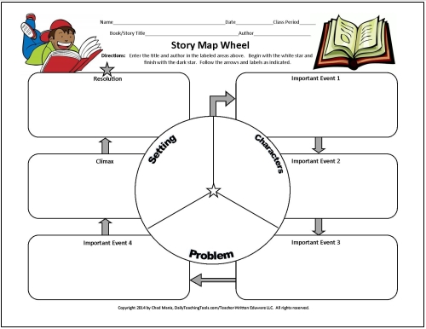

Climax

Resolution

Important event 1

Task2 的呈现方式。

